Find User Defined Function (UDF) By Its Name Or Partial Name

Using Transact-SQL Statements

To find a user defined function by its full name or part of the name, you can use transact SQL statements against the system tables like **sys.objects**, **sys.procedures**, **Information_Schema.Routines** or **syscomments**.

1. Using Sys.Objects

Using the sys.objects system view you can get list of UDFs by filtering the object type. In order to search for a specific UDF by its name, use the **name** column of sys.object.

|  |  |
| --- | --- |
| 1  2  3  4  5  6  7  8  9  10  11  12  13 | USE WideWorldImporters;  GO  SELECT       Name AS 'Function Name',       SCHEMA_NAME(schema_id) AS 'Schema',       type_desc AS 'Function Type',       create_date AS 'Created Date'  FROM       sys.objects  WHERE       Type in ('FN', 'IF', 'FN', 'AF', 'FS', 'FT') And       Name like '%Price%';  GO |

[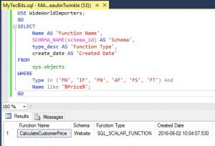](http://www.mytecbits.com/wp-content/uploads/SQL-Server-Find-User-Defined-Function-01.jpg)

2. Using Information_Schema.Routines

Using Information_Schema.Routines, you can filter the UDFs with the Routine_Name column. Here is the sample query.

|  |  |
| --- | --- |
| 1  2  3  4  5  6  7  8  9  10  11  12  13  14 | USE WideWorldImporters;  GO  SELECT      ROUTINE_NAME,      ROUTINE_DEFINITION ,      ROUTINE_SCHEMA,      DATA_TYPE,      CREATED  FROM      INFORMATION_SCHEMA.ROUTINES  WHERE      ROUTINE_TYPE = 'FUNCTION' AND      ROUTINE_NAME LIKE '%Price%';  GO |

[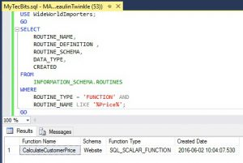](http://www.mytecbits.com/wp-content/uploads/SQL-Server-Find-User-Defined-Function-02.jpg)

3. Using Syscomments

In Syscomments, you can filter the UDFs using the OBJECT_NAME and OBJECTPROPERTY functions. Below the sample code.

|  |  |
| --- | --- |
| 1  2  3  4  5  6  7  8  9  10  11  12 | USE WideWorldImporters;  GO  SELECT      DISTINCT OBJECT_NAME(id)  FROM      syscomments  WHERE      (OBJECTPROPERTY(id, 'IsInlineFunction') = 1 OR      OBJECTPROPERTY(id, 'IsScalarFunction') = 1 OR      OBJECTPROPERTY(id, 'IsTableFunction') = 1) AND      OBJECT_NAME(id) LIKE '%Price%'  GO |

[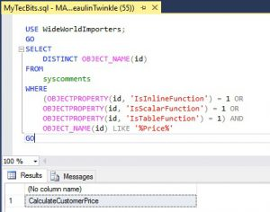](http://www.mytecbits.com/wp-content/uploads/SQL-Server-Find-User-Defined-Function-03.jpg)

4. Using Sys.Sql_modules

Just like Syscomments you can use Sys.sql_modules system catalog view as well. Here is the sample query.

|  |  |
| --- | --- |
| 1  2  3  4  5  6  7  8  9  10  11  12  13 | USE WideWorldImporters;  GO  SELECT      DISTINCT OBJECT_NAME(object_id) AS 'Function Name',      OBJECT_SCHEMA_NAME(object_id) AS 'Schema Name'  FROM      sys.sql_modules  WHERE      (OBJECTPROPERTY(object_id, 'IsInlineFunction') = 1 OR      OBJECTPROPERTY(object_id, 'IsScalarFunction') = 1 OR      OBJECTPROPERTY(object_id, 'IsTableFunction') = 1) AND      OBJECT_NAME(object_id) LIKE '%Price%';  GO |

[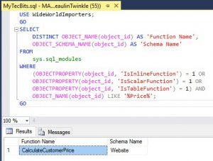](http://www.mytecbits.com/wp-content/uploads/SQL-Server-Find-User-Defined-Function-04.jpg)

Using Filter Settings In SSMS Object Explorer GUI

Yet another easiest way to find the user defined function by its partial name is using the SQL Server Management Studio (SSMS) Object Explorer window’s filter settings. In case if you are not familiar with this method, just follow the below steps.

1. In the Object Explorer in SQL Server Management Studio, go to the database and expand it.
2. Expand the Programmability folder.
3. Expand the Functions folder. Under the function folder, you can find sub folders for each type of UDF.
4. Right click one of the folders and select Filter >> Filter Settings.  
   [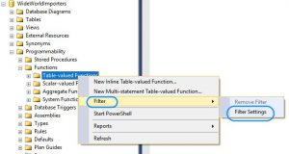](http://www.mytecbits.com/wp-content/uploads/SQL-Server-Find-User-Defined-Function-05.jpg)
5. In the filter settings window, enter the partial name of the function against the Name property. Click OK.  
   [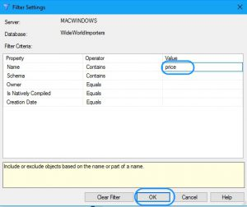](http://www.mytecbits.com/wp-content/uploads/SQL-Server-Find-User-Defined-Function-06.jpg)
6. In the Function type dub folder, only the UDFs containing the name will be listed.

You may be interested in [finding UDFs having text or table or column name](http://www.mytecbits.com/microsoft/sql-server/find-user-defined-function-containing-text-table-name).

Reference

* Multiple [methods to search and find stored procedures](http://www.mytecbits.com/microsoft/sql-server/search-find-stored-procedure) in SQL Server.